ProjectDesignPhase-ISolutionArchitecture

|  |  |
| --- | --- |
| Date | 28September,2022 |
| TeamID | PNT2022TMID37233 |
| ProjectName | Real-Time Communication SystemPoweredby AIforSpeciallyAbled |
| MaximumMarks | 2Marks |

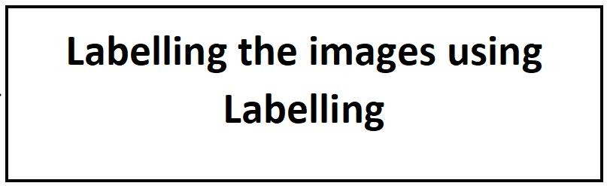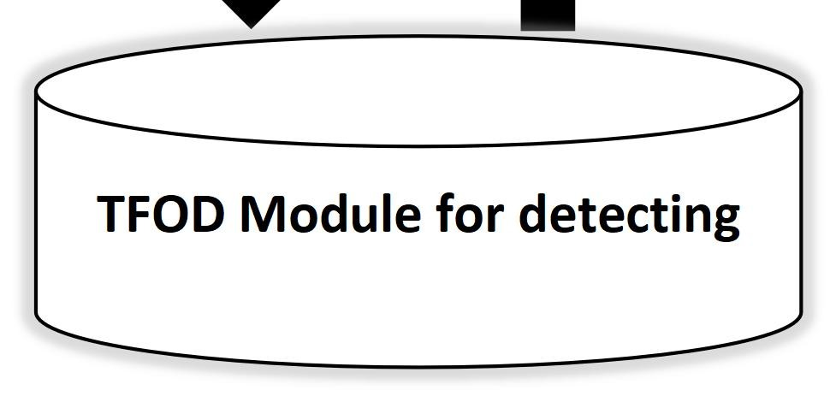

DD

SYSTEMARCHITECTURE